## Introduction

Flying a Quad copter is all about controlling motor rotational speed to maneuver it in any direction desired. However knowing the angle the Quad copter is leaning in any axis is also crucial as without this, it would be difficult to control the motor rotational speed within desired boundaries. The leaning angle tells us how much motor speed needs to be increased or decreased to get the Quad copter in suitable orientation. Every Quad copter has 3 basic angles that we need in order to control the Quad copter. They are roll, pitch and yaw.

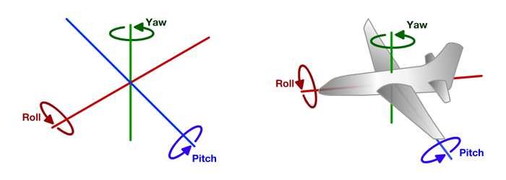

Z-axis

Y-axis

X-axis

Figure 3.a: Quad copter angles.